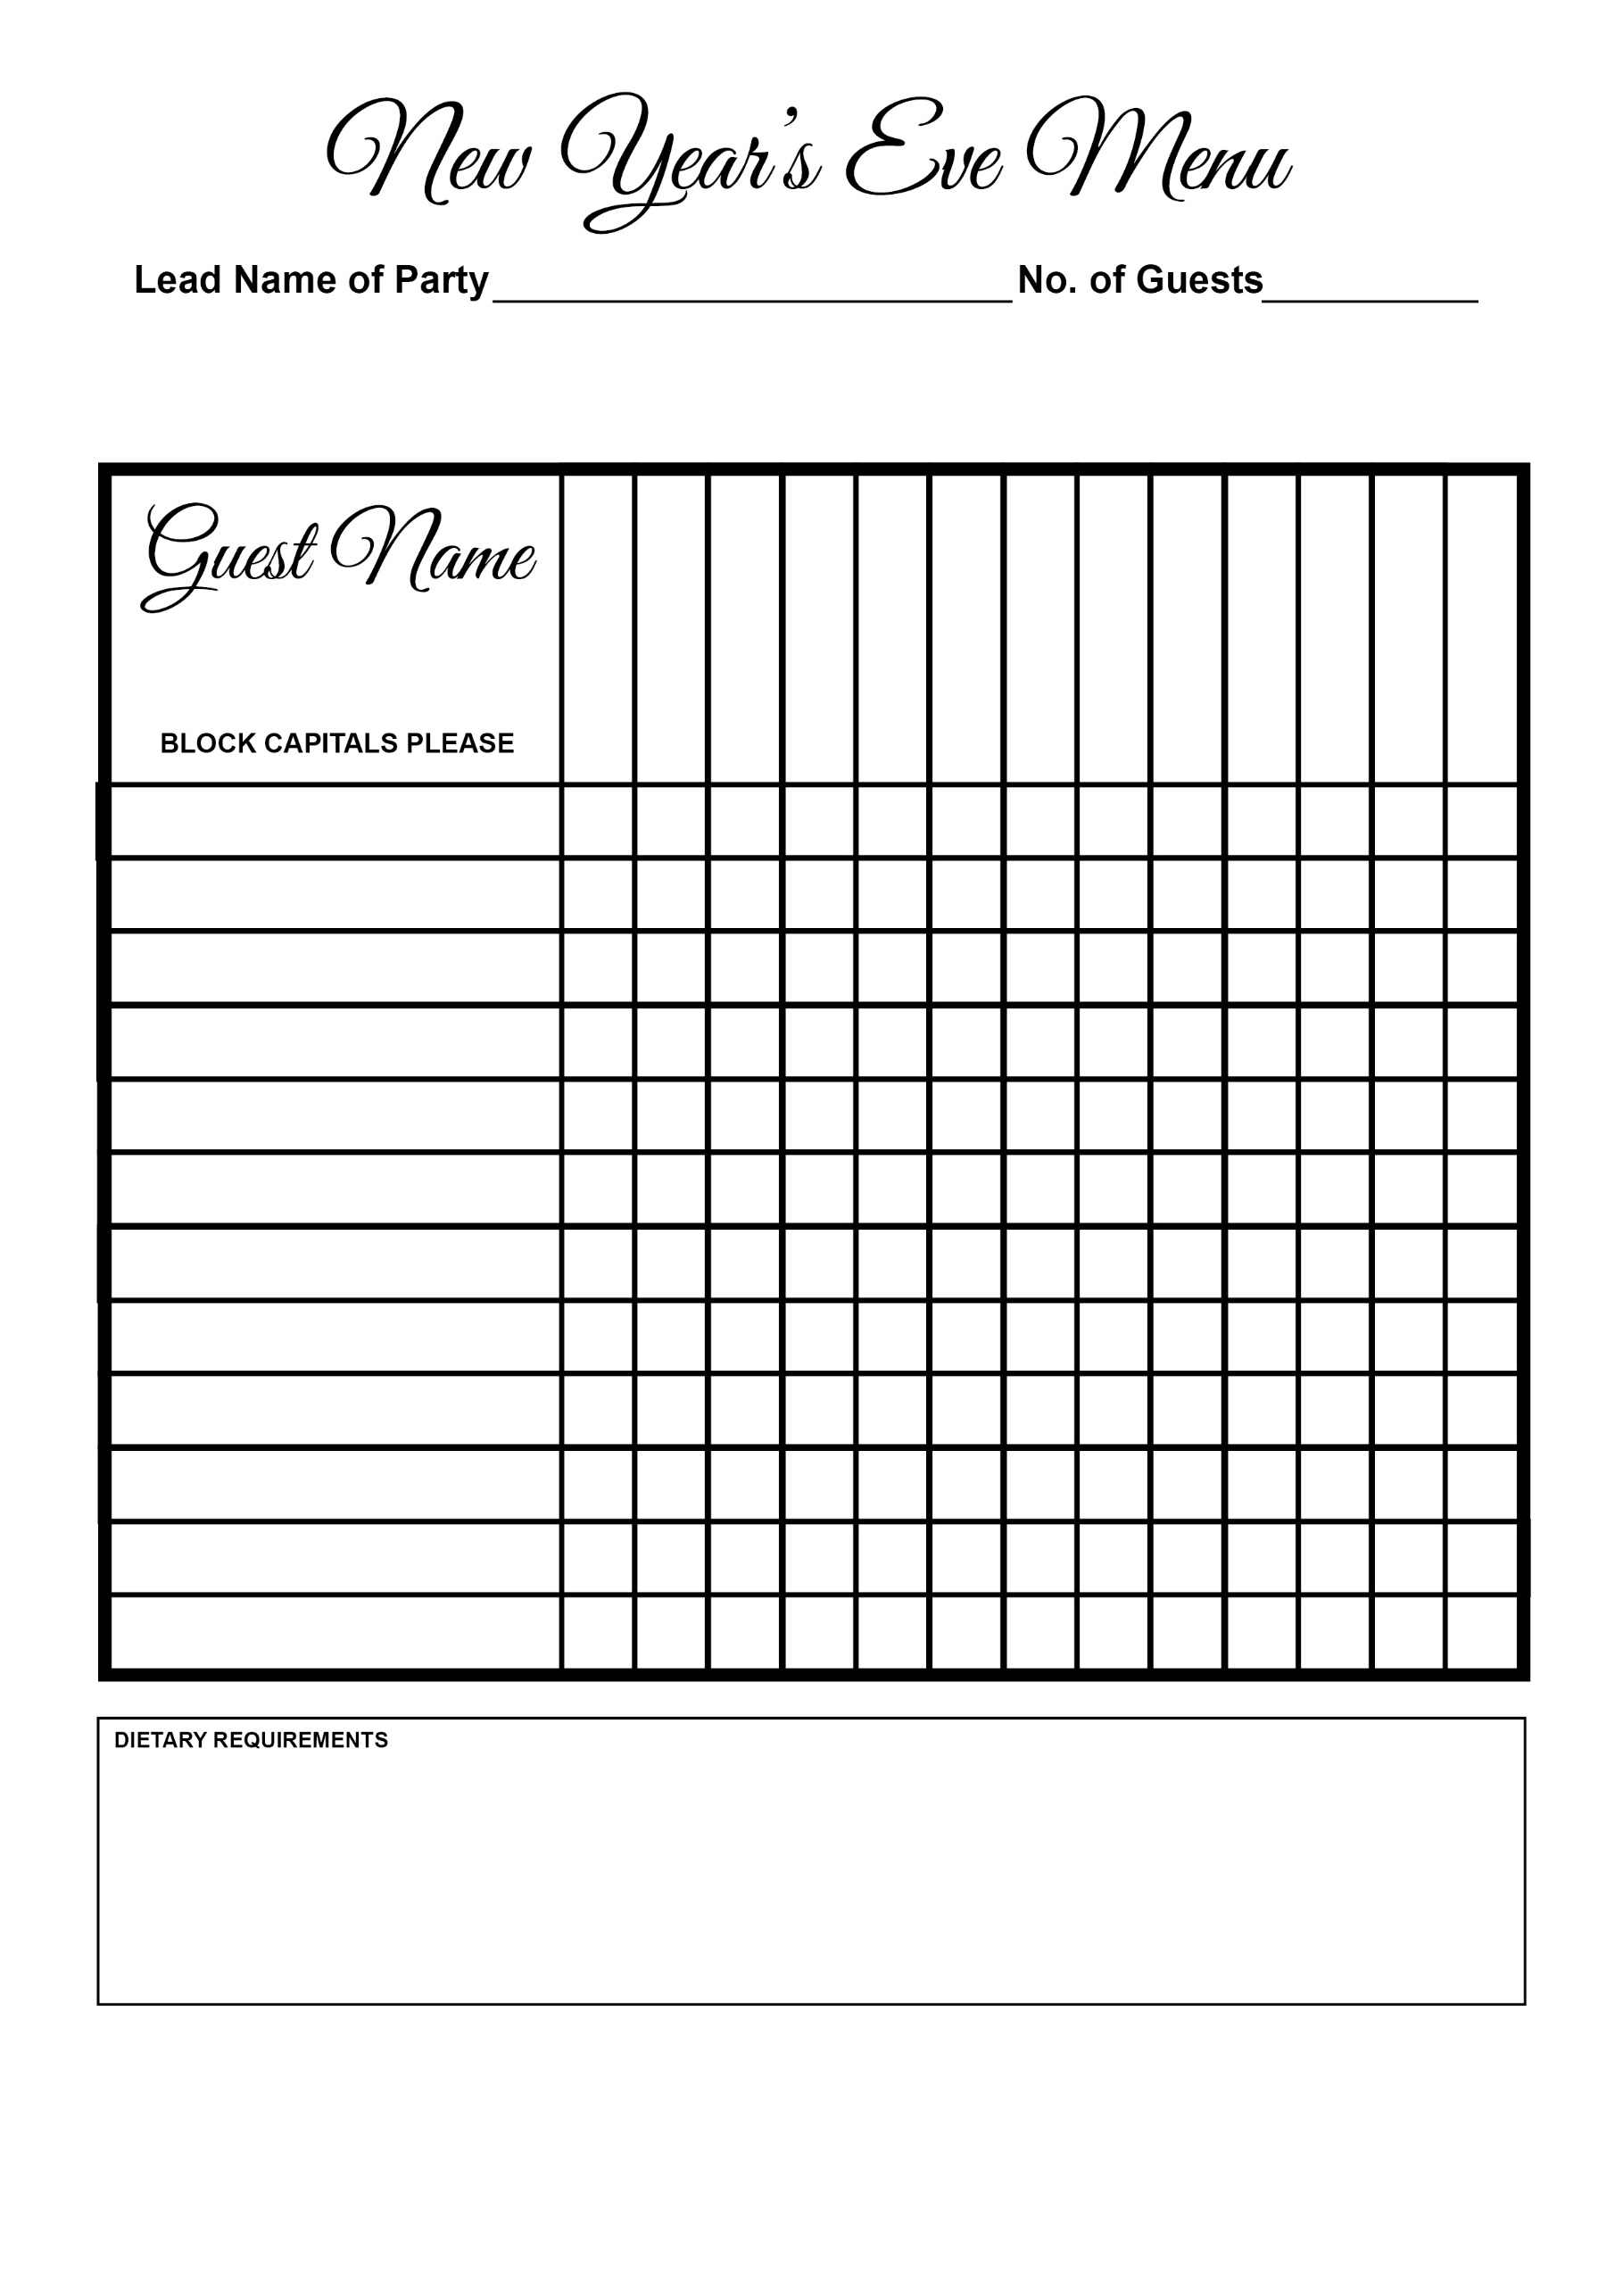

Roasted Pineapple

7 Textures Of Chocolate

Soup

Terrine

Scallops

Steak

Stone Bass